**Network Layer (layer 3 in OSI model) that is concerned actually getting data from one computer to another computer even if it is on remote network.**

**Network layer is one who deals with IP(internet protocol) in order for Layer3 devices(the devices that have IP address) we have to make sure IP(internet protocol) , default gateway , DNS (domain name system) is configured properly.**

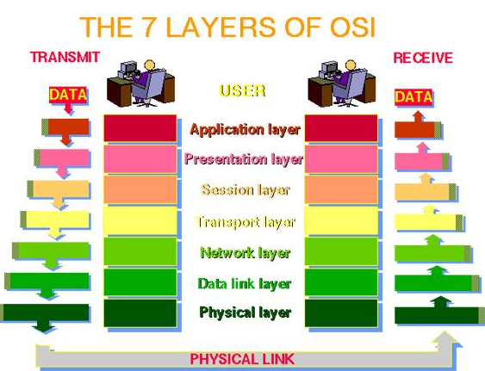

IPV4 addresses are unique and universal it is 32 bits long the total address space that can be used by IPV4 is 232 (4,294,967,296).

There are two types of addressing used in IPV4 (internet protocol version four).

1. Classful addressing: In classful addressing address space is divided into five classes A, B, C, D, and E.

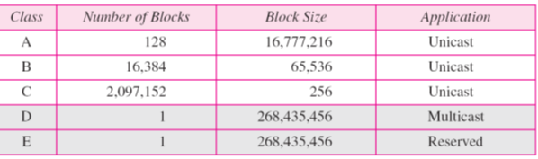

IP (internet protocol) address has two parts network part and host part .In class A we have 8 bits for network and 24 bits for host portion. It can be represented **as X.X.X.X/8** where X represent the IP address that belongs to class A.

For the class B we have 16 bits reserved for network and 16 bits for host portions for class C we have 24 Bits for network portion and 8 bits for host portion.

Class D is reserved for experiment and Lab uses it can only contains multicast addresses while class E is reserved and not being used currently.

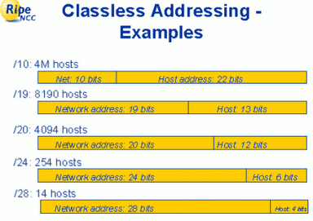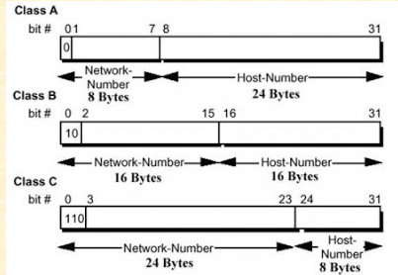

In classful addressing we have either class A means /8, B means /16, C means /24 inside our network. As total number of IP addresses that can be supported by class A is (2^24)-2 we have to subtract two because first bit is reserved for Network address and last addresses is reserved for broadcast address. So in case if our network consists of few devices and we are using class A, B or C large portion of IP addresses will be wasted.

Another disadvantage of classful addressing is that it did not send subnet information rather it sends the complete network address.

In order to save the IP (internet protocol) addresses classless addressing is used classless addressing is also called **CIDR (classless inter domain routing) .**In this scheme it is not necessary to have /8, /16 or /24 for host portion. We have to decide the host portion based on network requirement.

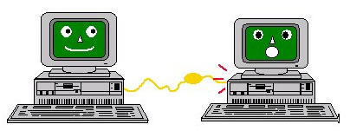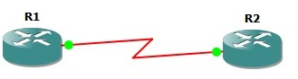

/300

/300

For example if we want to connect two PC we will be using /30 instead of using /8, /16 or /24

/30 means total number of IP address that can be formed will be (2^2)-2 =4 thus we can avoid the wasted of IP (internet protocol) addresses.

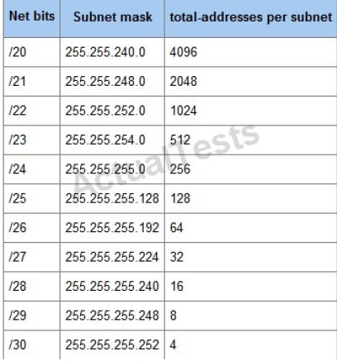

It is always important to check the configuration done and if possible make amendments for example. In Router we have to give IP addresses to every interface that is being used and in order to check the IP addresses that have been configured on router interfaces we can use the command “show ip interfaces brief” without quote

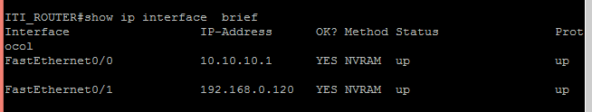

Protocol show the status of interface if it must be up in order for it to communicate over the network.

And in order to assign IP (internet protocol) address to any interface on cisco router we have to use the command .

In order to assign Ip address to any interface on the router use the command

R1#configure terminal

R1(config)#interface fa0/0 // or it can be any interface

R1(config-if)# 192.168.0.1 255.255.255.0

R1(config-if) no shut

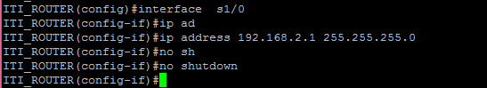

But before making telnet connection to your router make you’re your router is configured to support Telnet.

Then to make Telent access to your remote you can use cmd (command prompt) or third party software known as Putty. If connection is being established provide your username and password that are confidential and are configured by system administrator.

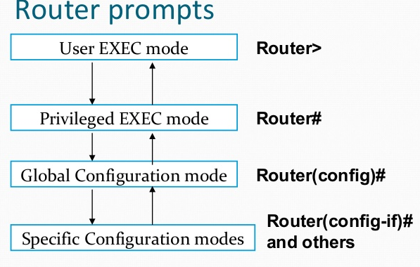

After providing the information you will be inside the user-access mode from this mode put “enable” without quote to go for privilege-executive mode. Then in order to configure your router enter the command “configure terminal” and here you can make configuration changes.

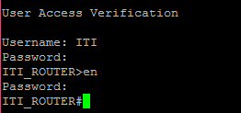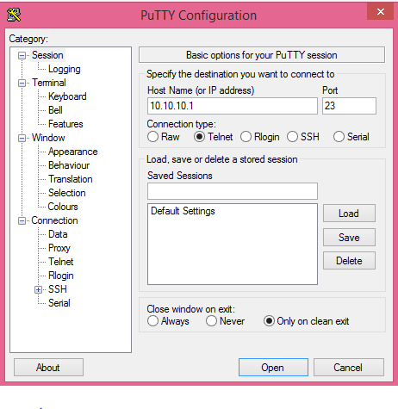

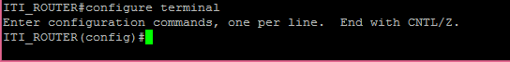

**Configuring Telnet on cisco Router or Switch**

**In order to enable telnet access on your cisco router or switch we have to follow these steps notice VTY (virtual teletype) lines are used to make remote connection to device. Here line VTY 0 4 mean four remote connections can be established at the same time.**

**While service password-encryption means password will be encrypted. After you have configured these command on Cisco router or switch go to cmd or putty and make the telnet connection.**

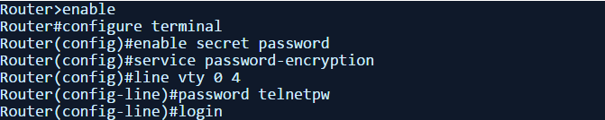

In order to make telnet connection to cisco switch it is compulsory to make vlan (Virtual local area network) and assign IP (internet protocol) .

The reason is because Switch (layer two devices) deals with Mac-address this the reason it must be configured with vlan.

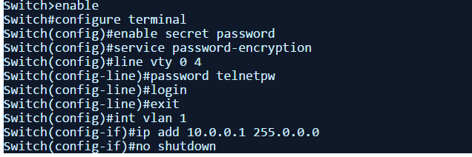

Now go to your PC and make telnet connection to remote switch or router.

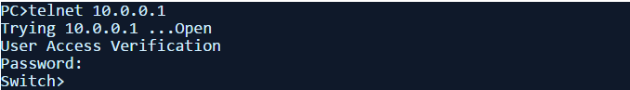

As we know SSH (secure shell) is same like Telnet but it is more secure than telnet the information is encrypted instead to being sent as clear text even if the outsider mange to get access inside the network they cannot interpret the information being sent or received. Older version of IOS of Cisco did not support SSH rather they support only Telnet.

In order to configure SSH on your cisco device follow the below procedure.

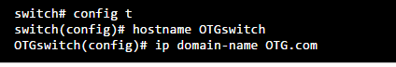

Hostname and domain-name you define whatever you want to define.

In the second step we have to create RSA keys

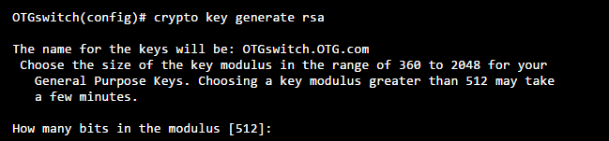

Choose 1024 for better security

**In the third step need to configure VTY lines**

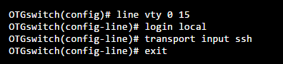

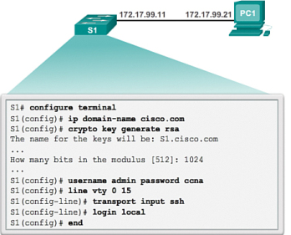

Ip address to PC can be assigned by using command as well from GUI (Graphical user interface),

In order to assign to PC by using the command line follow these simple steps

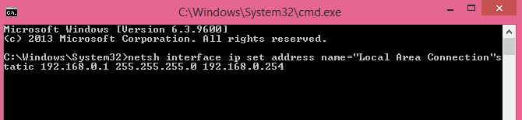

In the above configured IP address

* IP address assigned to PC is : 192.168.0.1
* Subnet mask is : 255.255.255.0 or /24
* Default Gateway is : 192.168.0.1

Or it can be assigned from the DHCP (Dynamic host configuration protocol) server by using this command

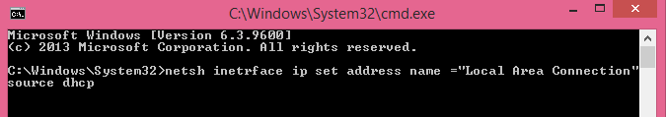

By using this command IP address, subnet mask, default mask, DNS (domain name system) information will be retrieved from DHCP (dynamic host configuration protocol).

**DNS (Domain name System)**

Domain name system is used to convert Domain names to IP address. For example when you type [www.google.com](http://www.google.com) firstly it will be converted into IP address by DNS (domain name system) then that IP address will be used.

**DHCP (Dynamic Host configuration protocol)**

When the network size is large it is not easy to assign IP address to every PC statically for this we use a service known as DHCP(Dynamic host configuration protocol) that assigned IP(internet protocol) address to PCs.

Changing IP address using GUI (Graphical user interface) follow these steps

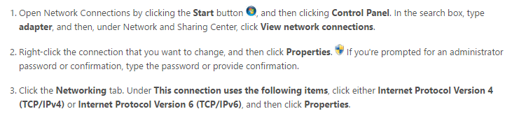

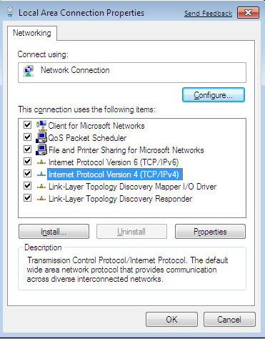

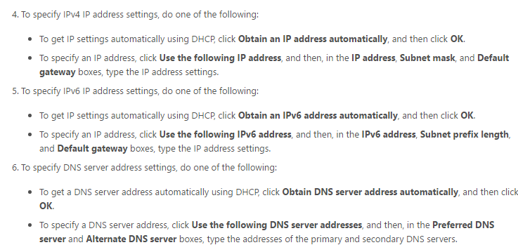

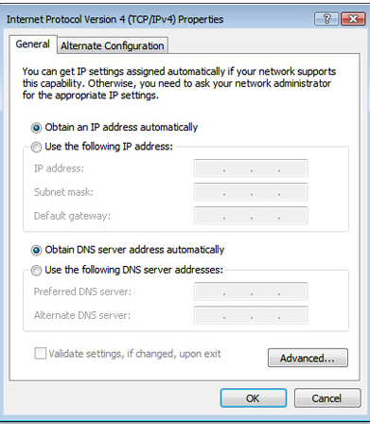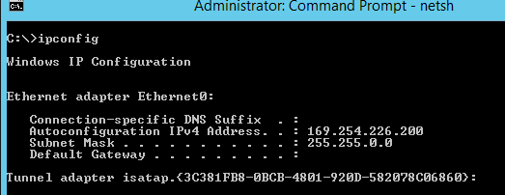

Quick Quiz

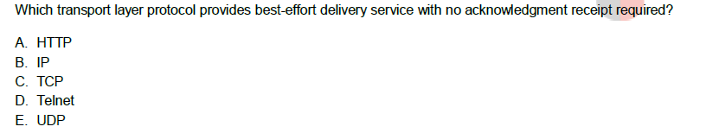

Answer: UDP (user datagram protocol) is considered as best effort delivery.

Which Method provides more secure connection between router and PC?

A. Telnet

B. SSH

C. HTTP

D. HTTPS

Answer: SSH (secure socket shell) provides more secure connection because information being passed is encrypted.

What should be value of RSA for better security in SSH (secure shell) connection

A. 1024

B. 524

C. 725

D. 948

What address will be more useful if we have only four PCs inside our network

A. 192.168.0.0/32

B. 192.168.0.0/30

C. 192.168.0.0/29

D.192.168.0.0/16

Answer: The best Answer will be 192.168.0.0/30 because it will waste minimum number of IP addresses (2^3)-2 =6 in /30 only two address can be supported only.

* We have use 2^3 because 32-29 =3